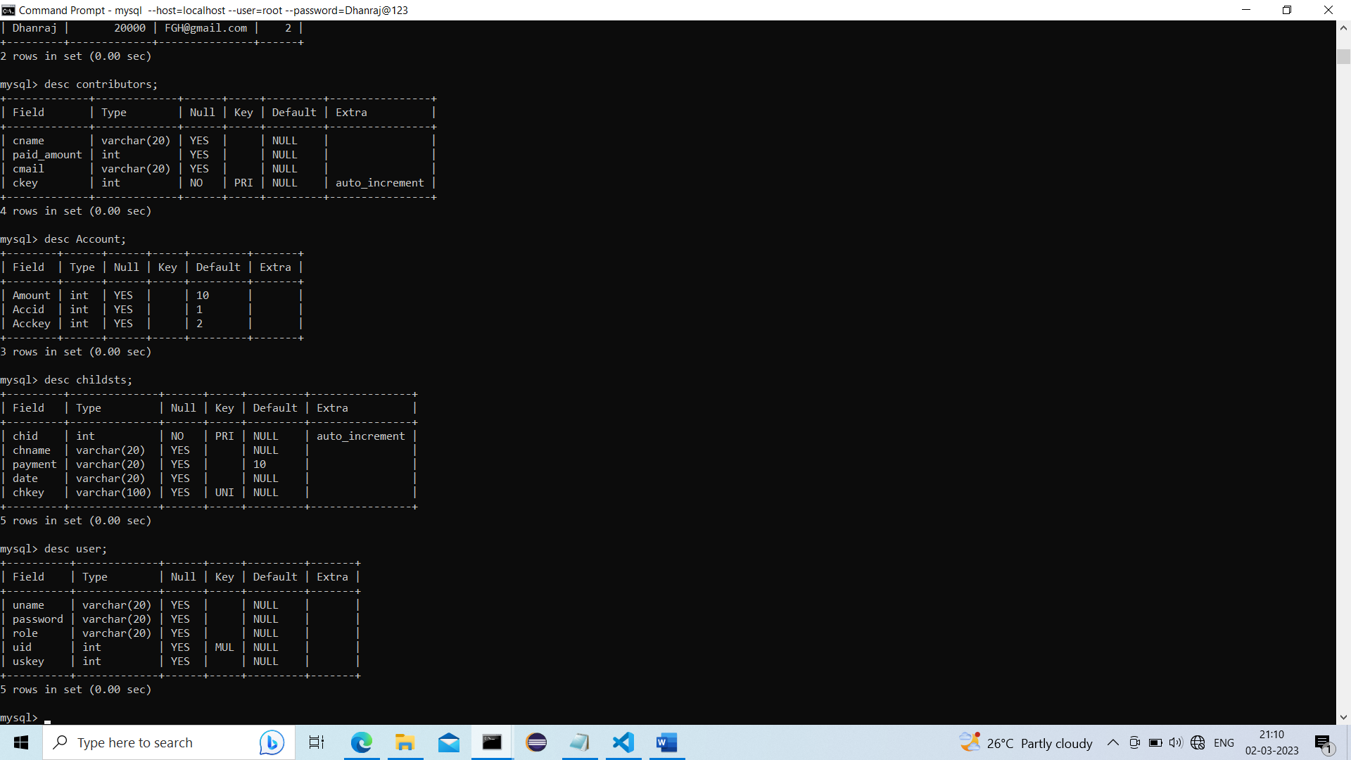

.>Description about 4 used Tables …..

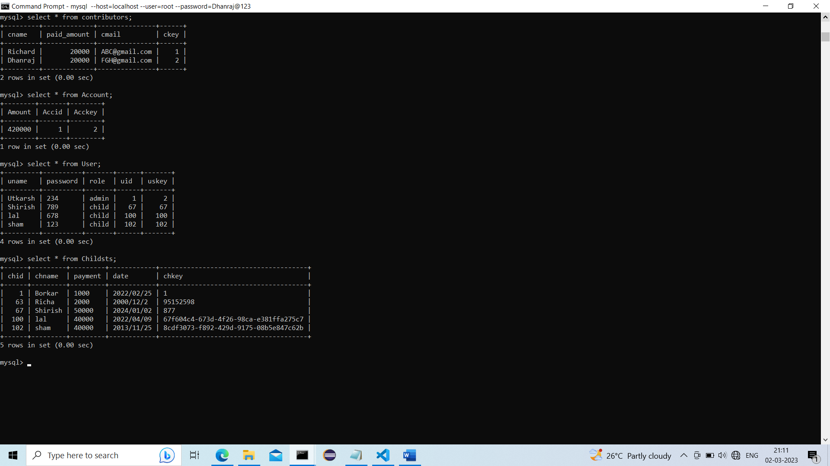

.>Relation/Entity/table containing it Attribute/column and tuple/row….

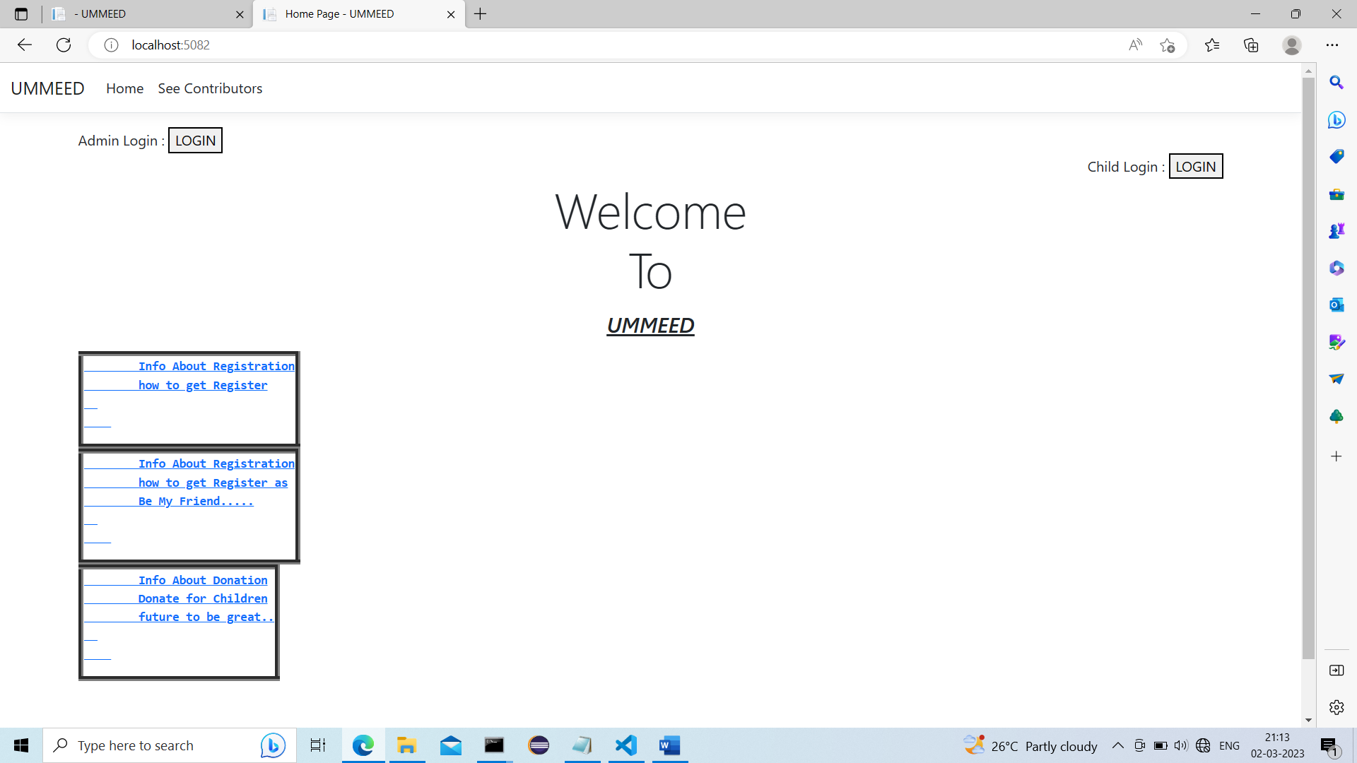

.>Landing page.. today on 02-03-2023 completed its backend work and arrangement of frontend is remaining….

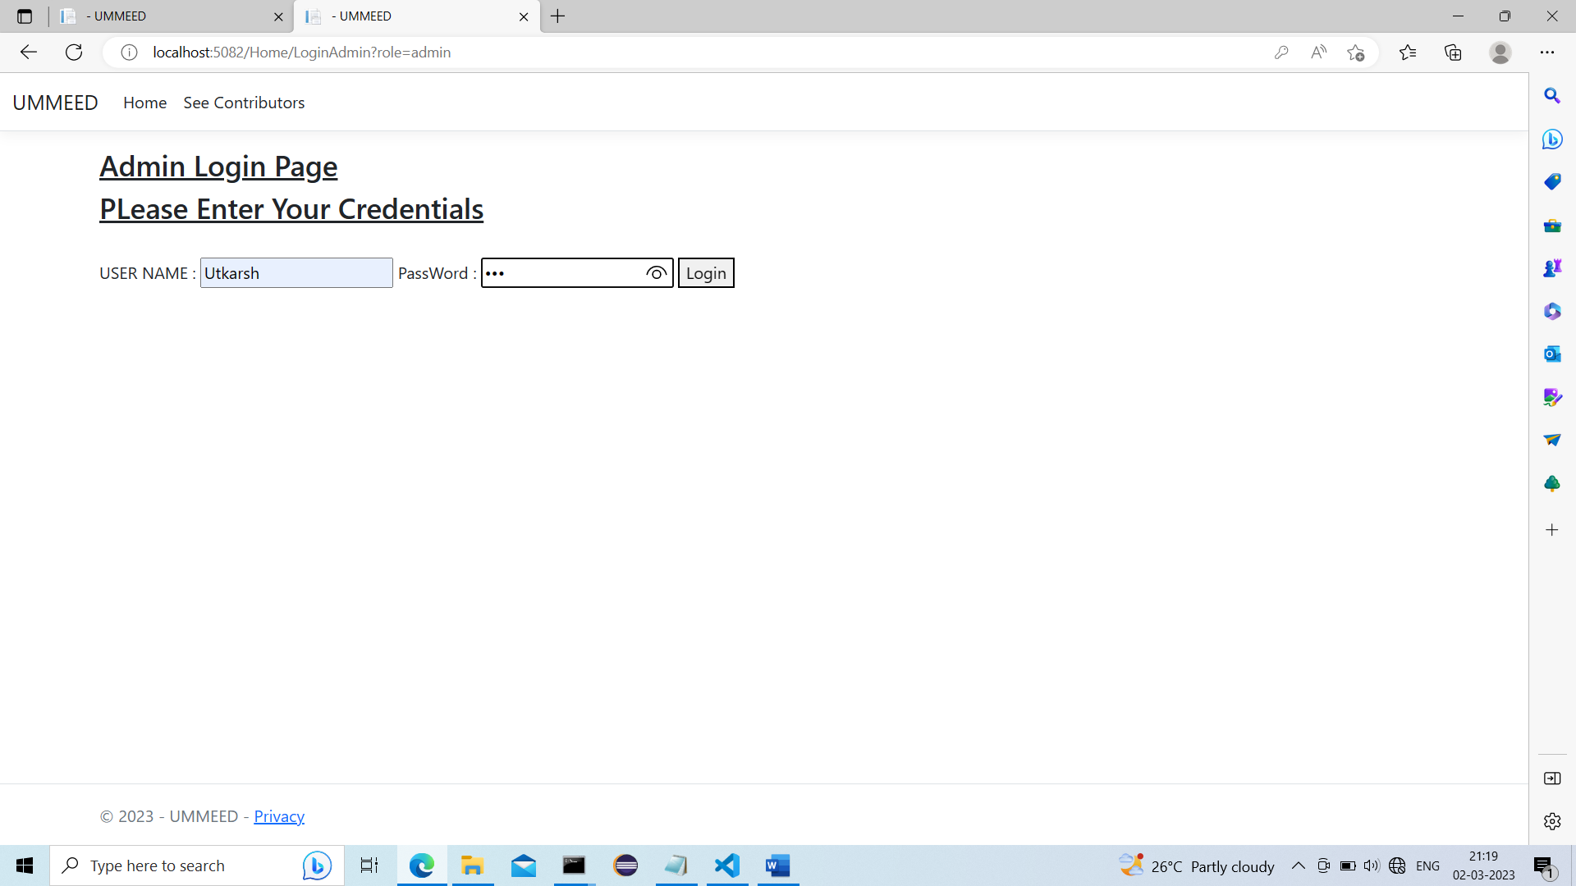

.>Admin Login Section..

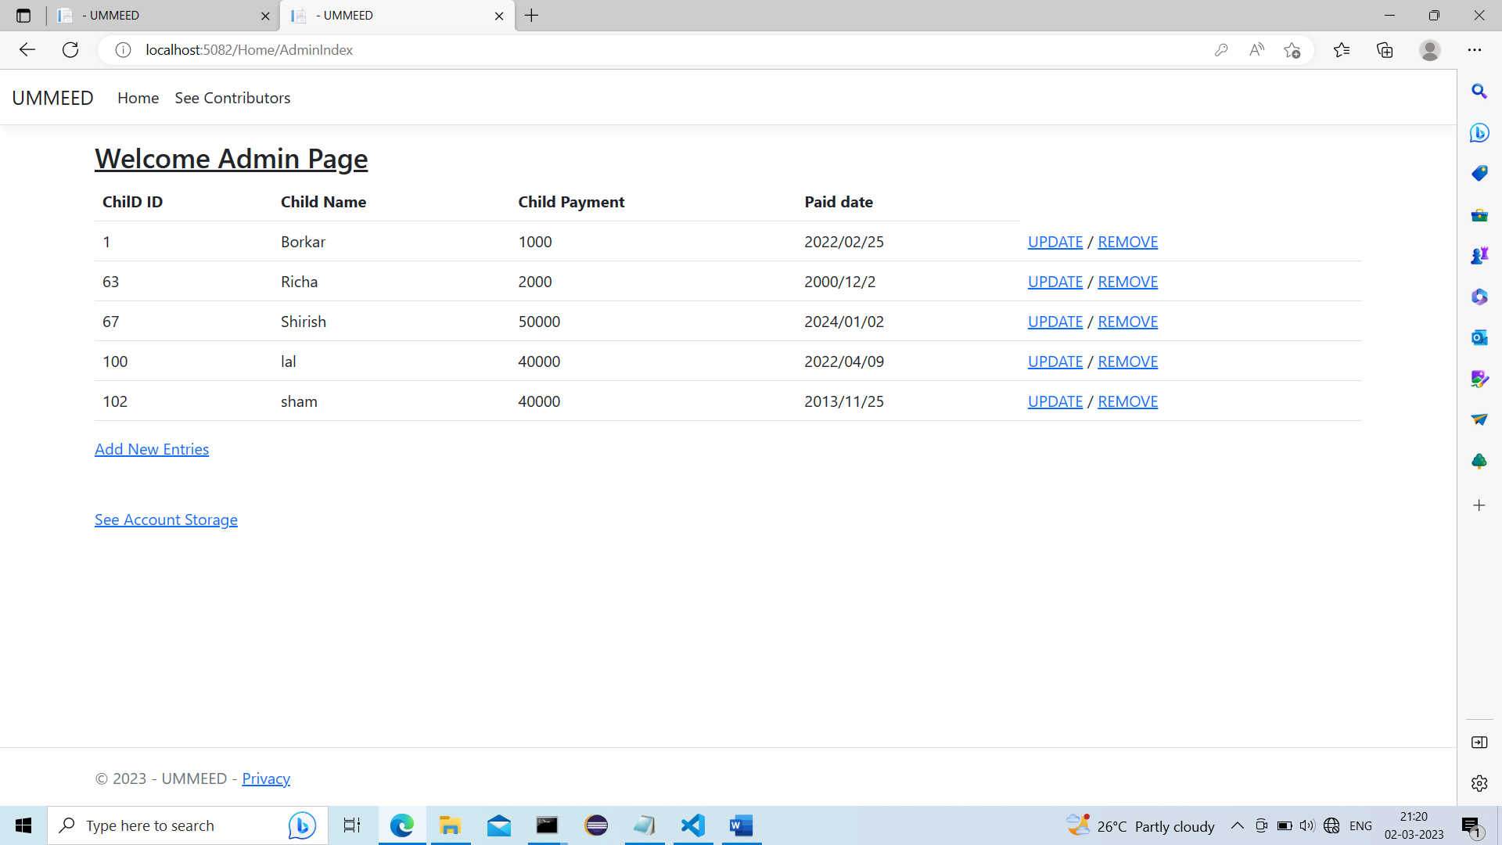

.>Admin Carrying All details of registered Children….

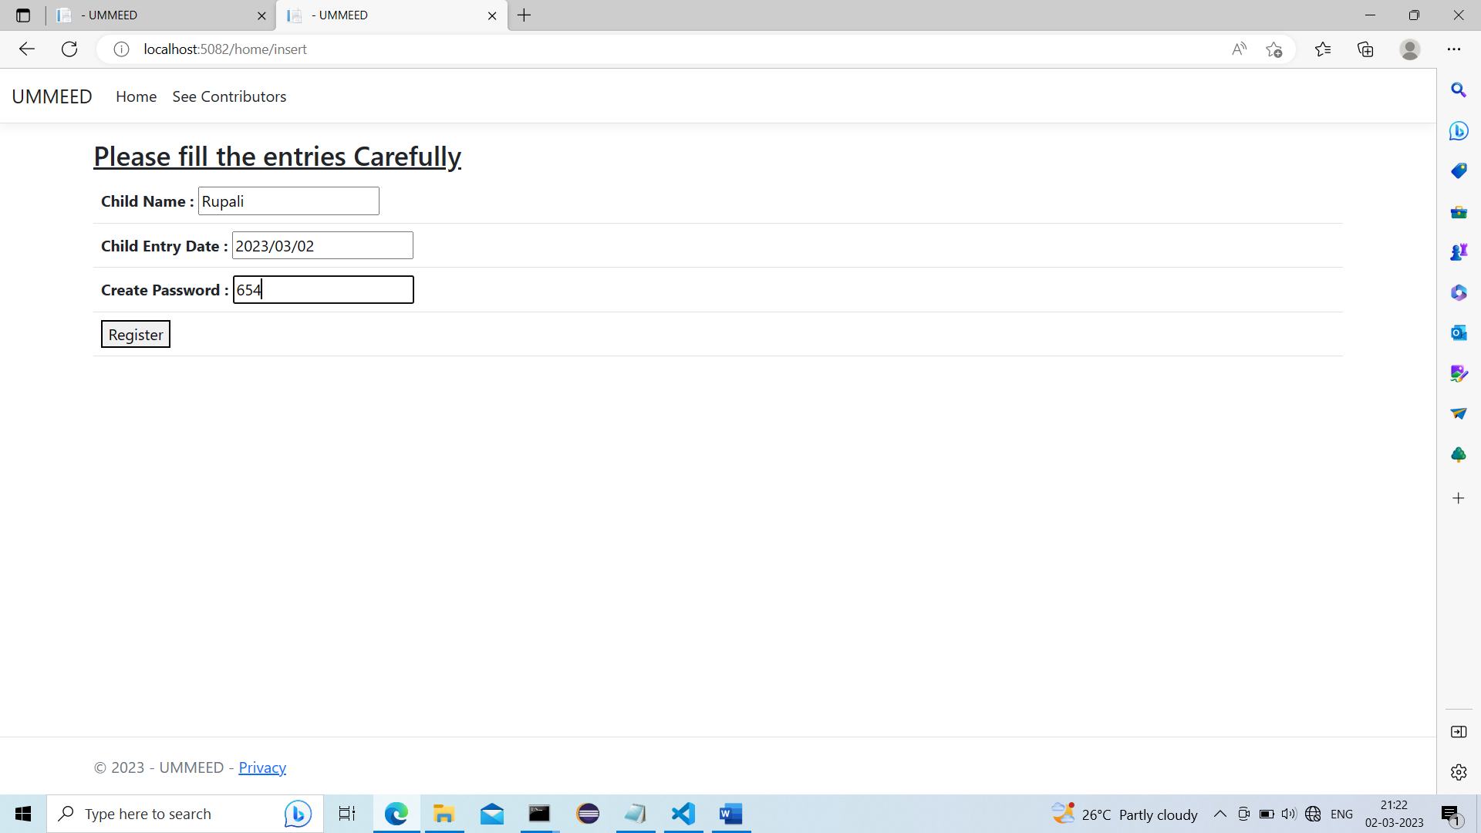

.>Registering new Child…

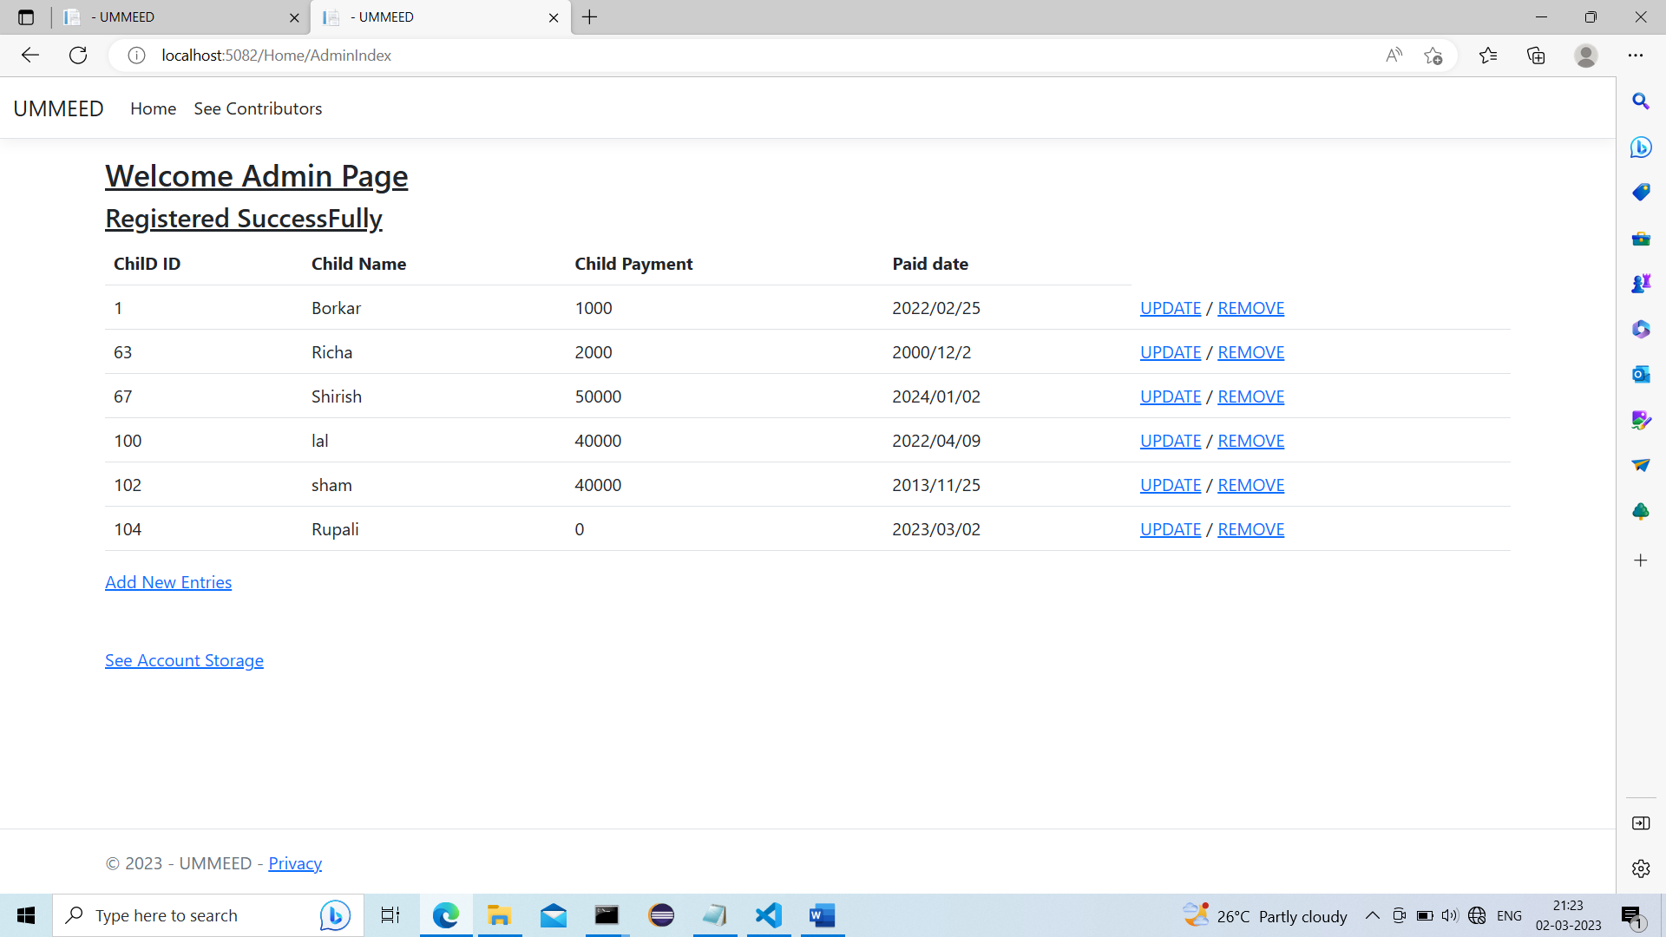.>New Child is Registered Successfully…

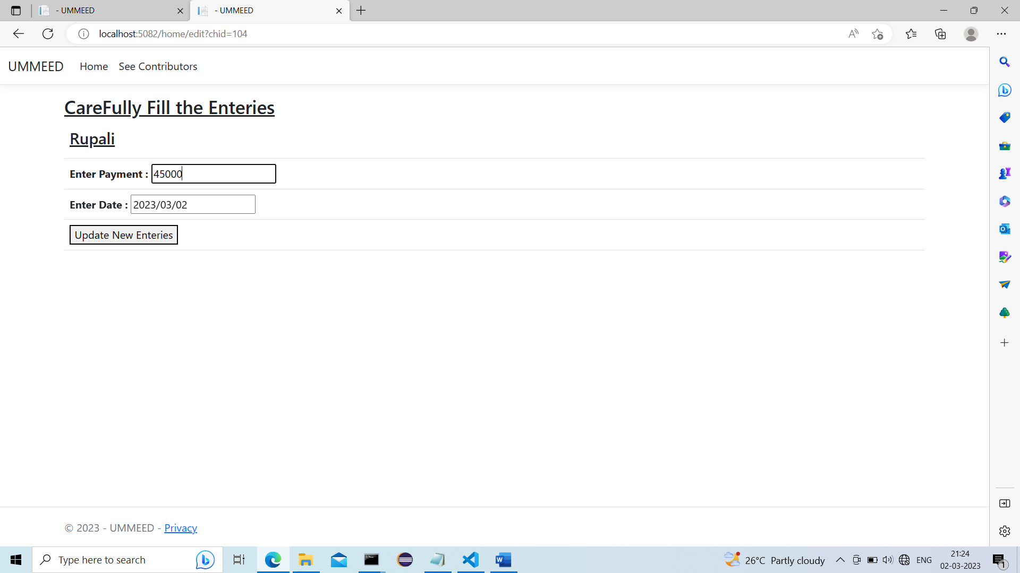

.>providing Child some donated Amount…

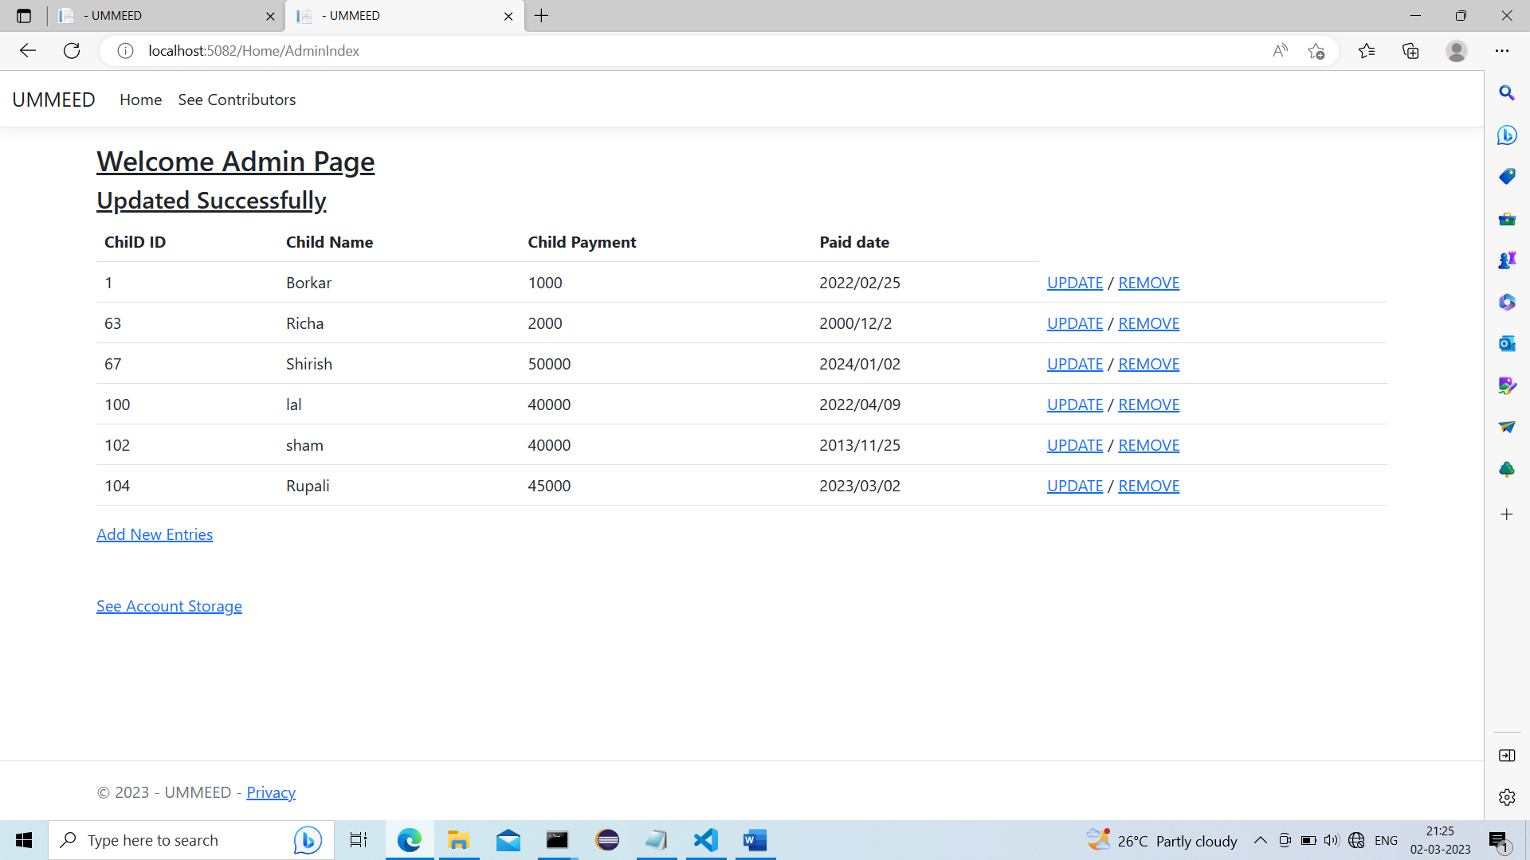

.>Amount is provided to Child…

.>When Amount is provided to child then amount is deducted from Donation Account..

.>Now we will remove child Rupali…

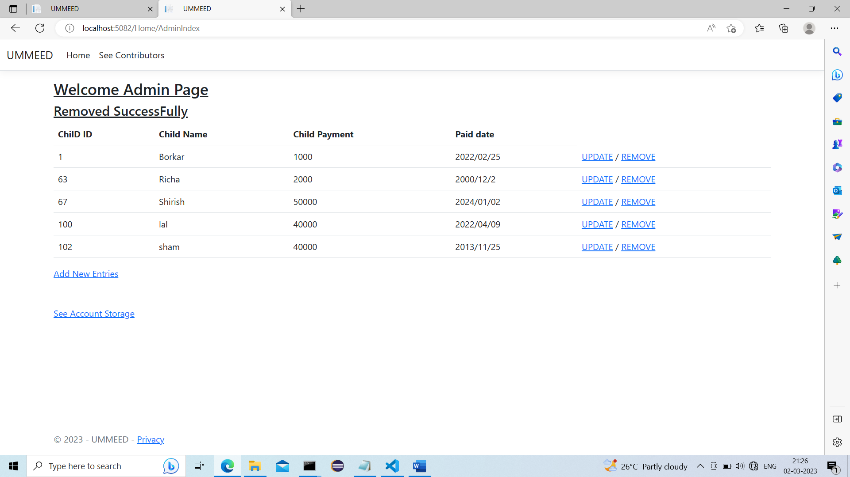

.>Child is Removed Successfully….

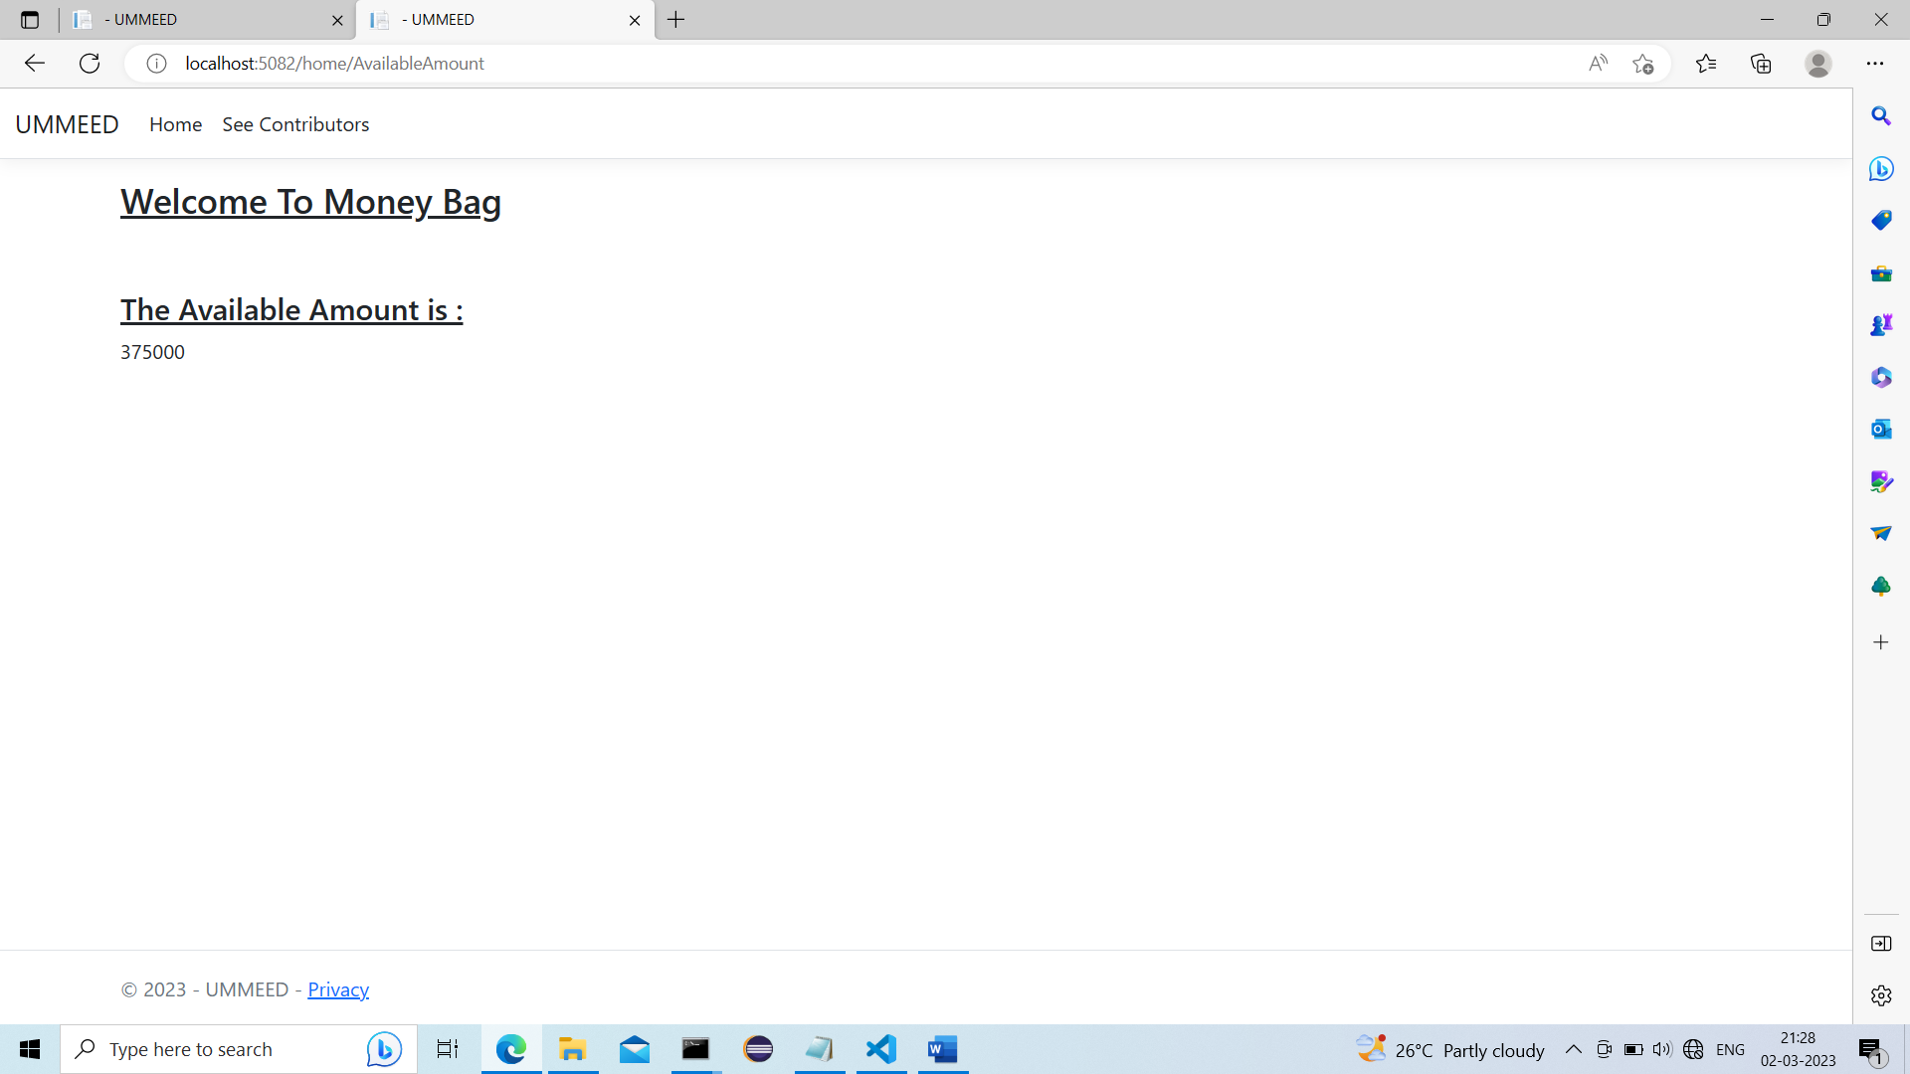

.>We can also check amount stored in Donation Account…

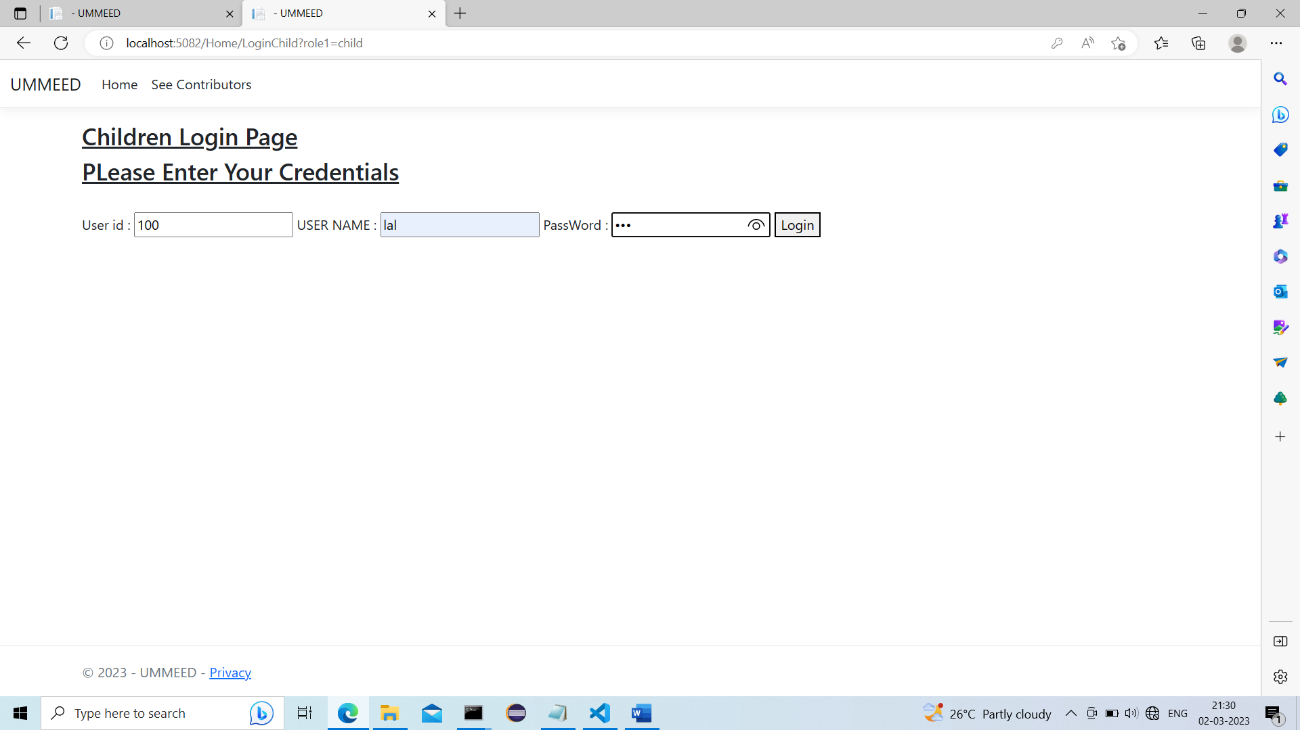

.>This is Children login page only Registered Children can login here..

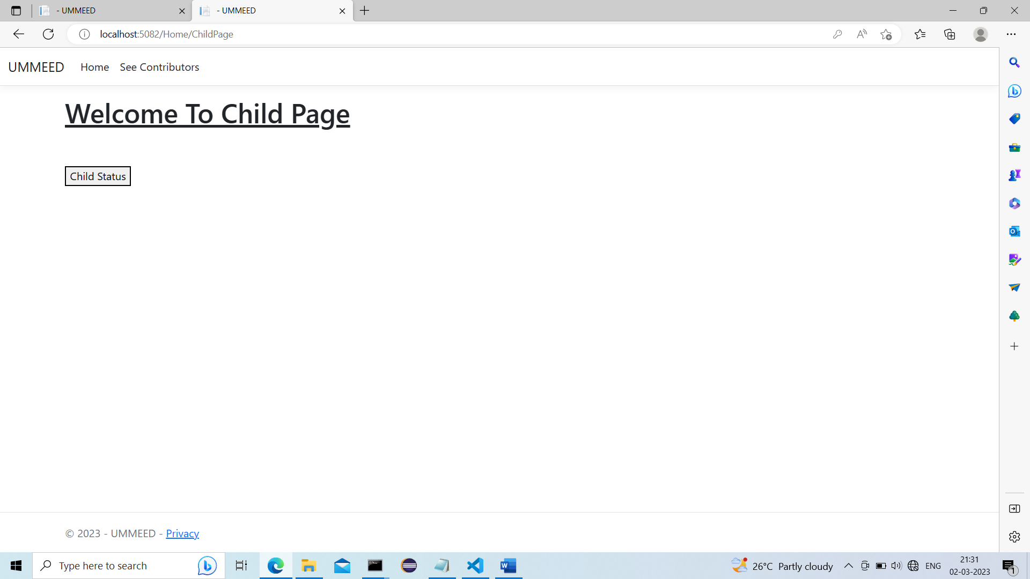

.>landing page of Child…

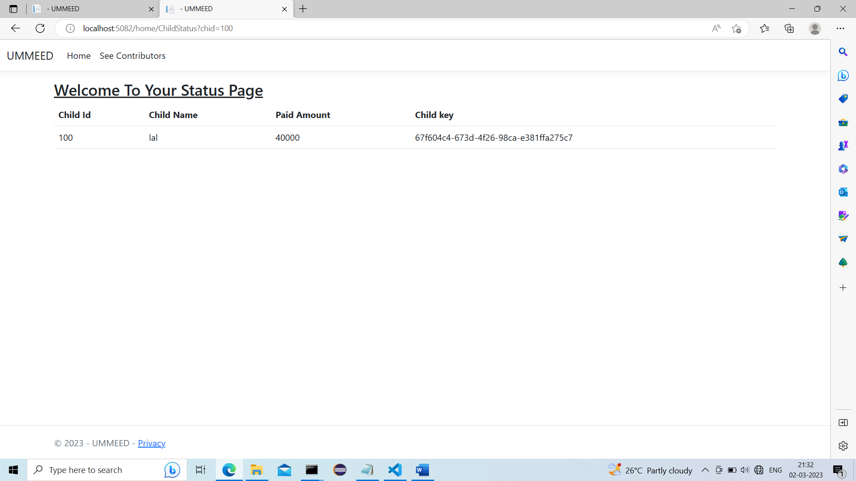

.>login child can check its status which is last recent updated……

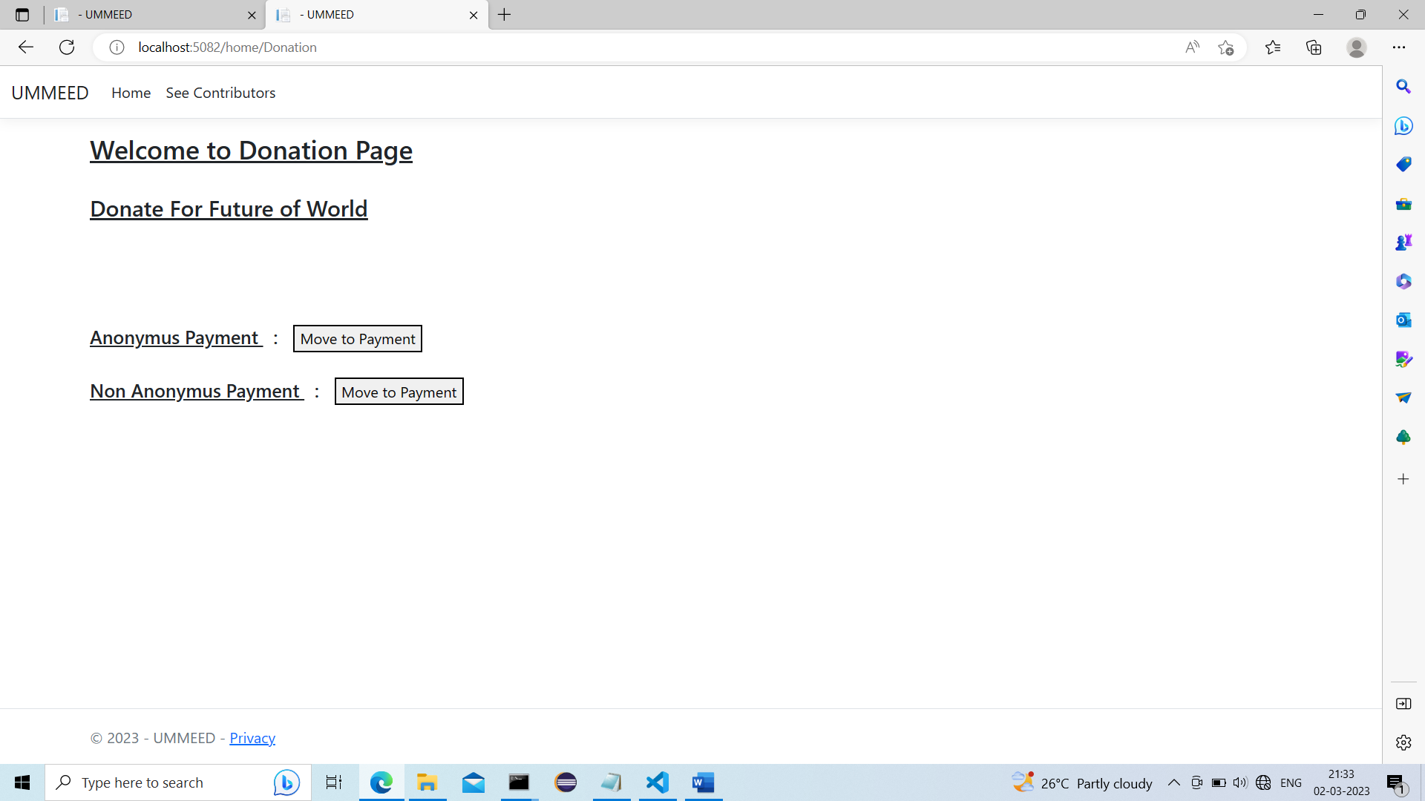

.>This is Donation page where Donation can be done Anonymously and Non Anonymously…

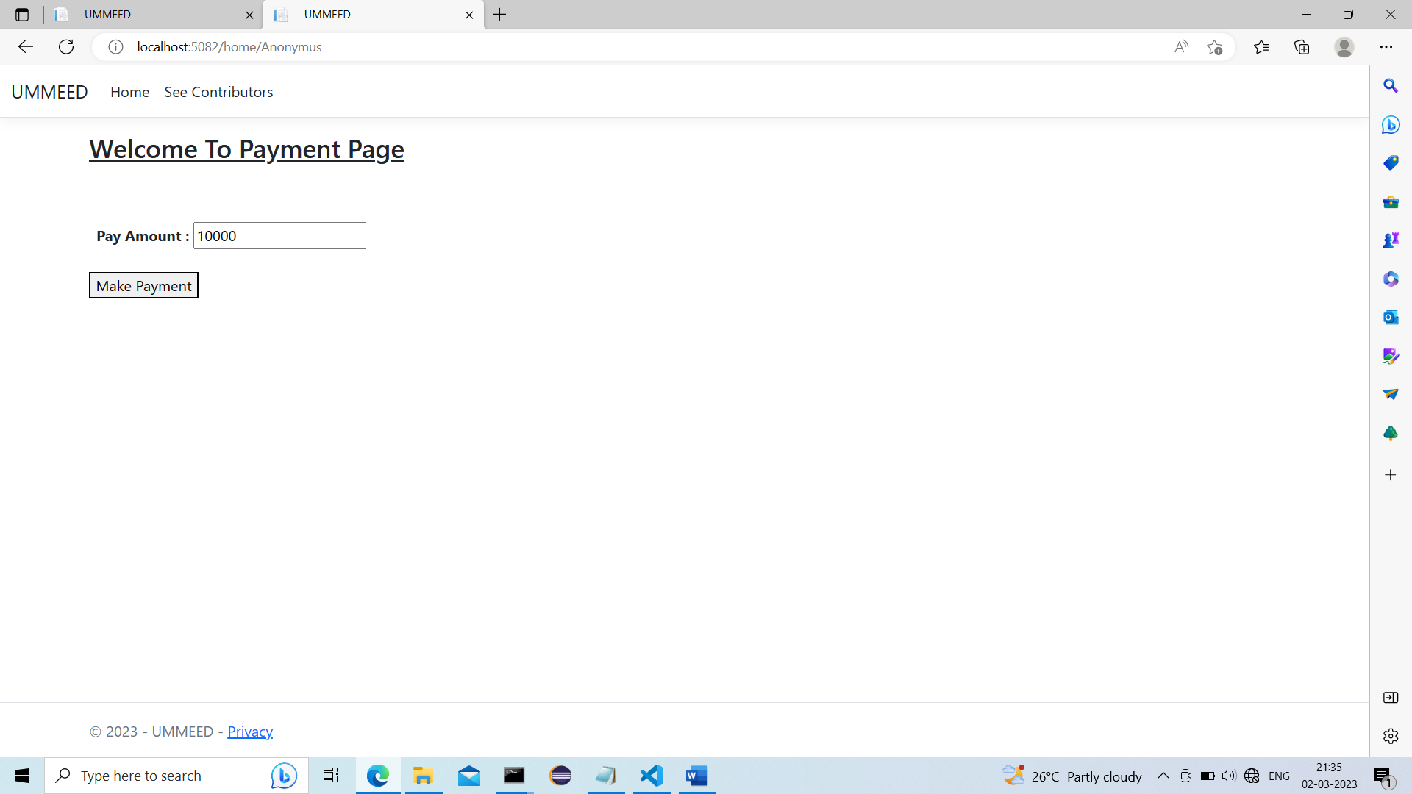

.>Anonymous Payment Page..

.>when payment is done it is added in Donation Account…logic is connected with each other

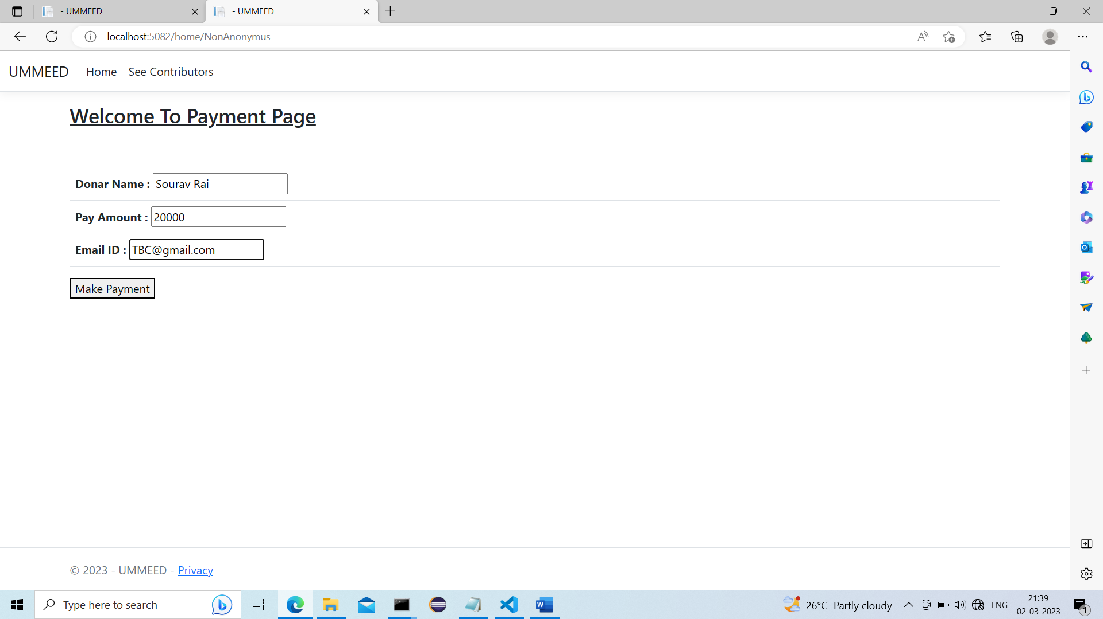.>This is non Anonymous payment section..

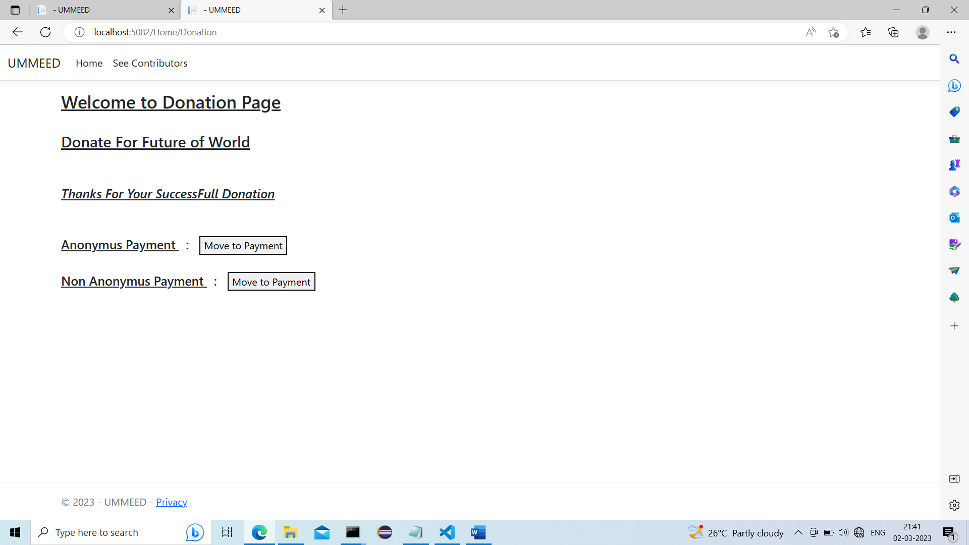

.>Payment is Successfully Donated and We can see even list Contributors who want to show there identity….

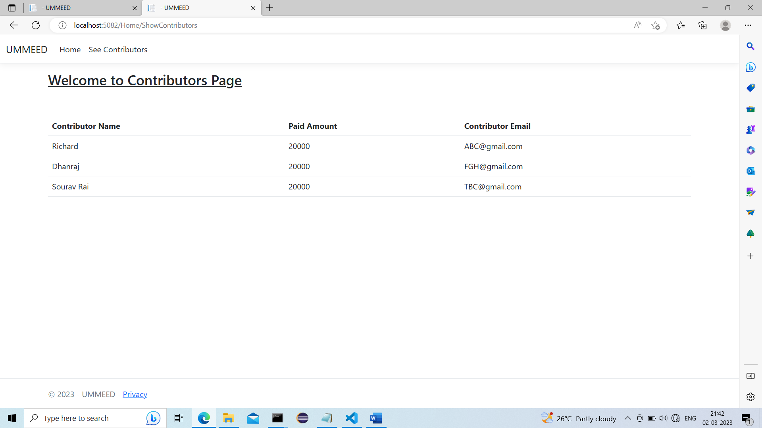

.>These are Contributors who had Donated till now….front end arrangement is in Automation..